Contents

87. Metadata Schema in AEM Assets 2

88. CSV Asset Importer 7

89. Annotating pages 14

90. Download AEM 6.4 feature pack 2 17

91. TouchUI Multifield Component – Part 1 19

92. TouchUI Multifield Component – Part 2 23

93. TouchUI Multifield Component – Part 3 28

# 87. Metadata Schema in AEM Assets

In this section, we will discuss about metadata schema in AEM assets

**AEM** --> **Assets** --> **Files** --> **Demo** Folder --> **Select** image -> **Properties**

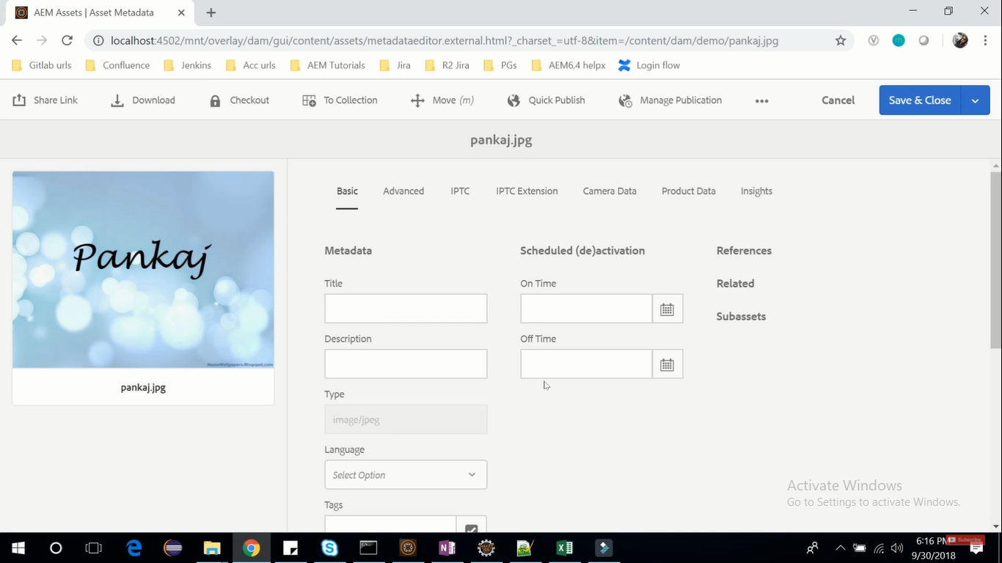

Here you will find lots of **metadata** that is attached with this image which AEM provides out of the box.

In the Basic tab, you can find metadata information about the image.

Suppose in this **Basic tab**, we want to **add 1 property** i.e **Upload Date** of this image.

We can do this using **Metadata Schema** functionality which Adobe improvise.

Open one more AEM instance. **AEM** --> **Tools** --> **Assets** --> **Metadata Schemas**

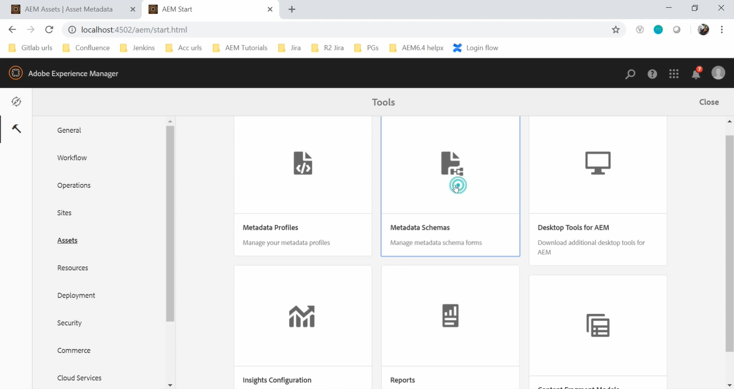

There we already have **4** **Metadata Schema** **Forms** (see image below).

The one with name **default** creates the schema which makes **Basic** tab of image Properties.

To add **1 more property** in **Basic** tab perform below steps:

Select this **default** schema --> **Click** on **Copy** icon on Toolbar --> Assign **name** as **MySchema**

This will create exact **replica of default** schema.

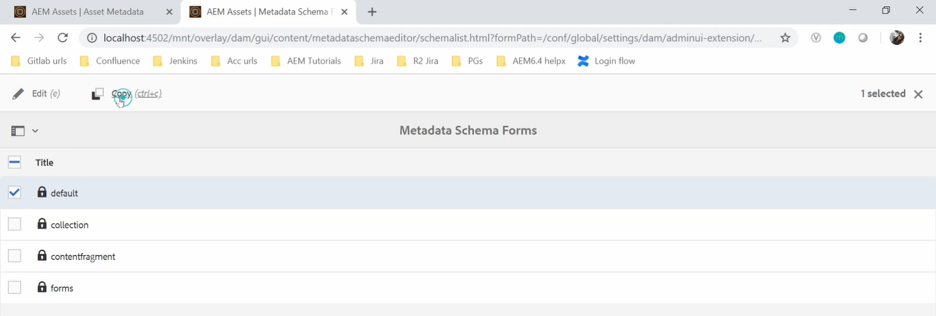

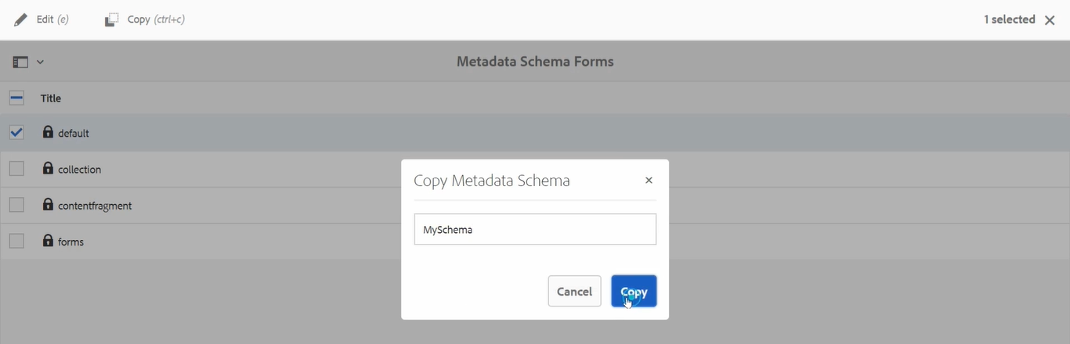

Select newly created **MySchema** --> **Click** on **Edit** icon on Toolbar.

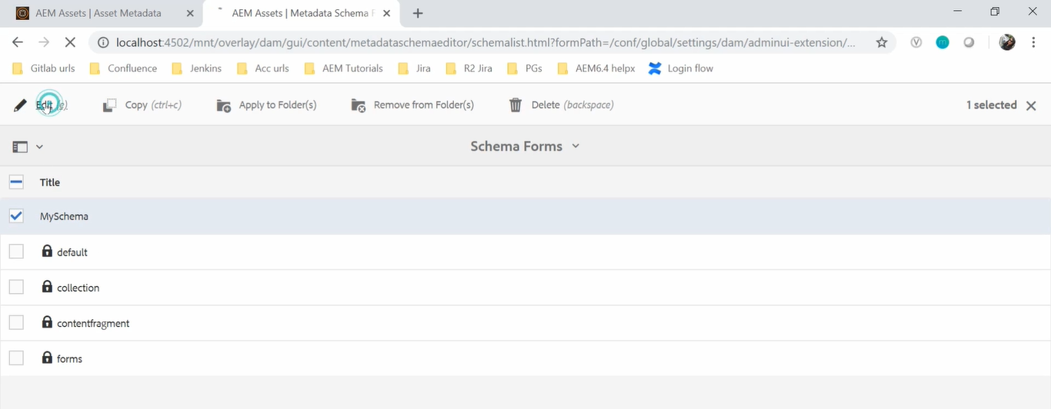

You will see **all the Properties tabs**. Now in **Basic** tab we need to add new property named **Upload Date**.

So, **drag** component **Date** from **Right Hand** **side** and **drop** somewhere on the **Basic** tab .

change the name from “**Default Value**” to “**Upload date**” and **Save**.

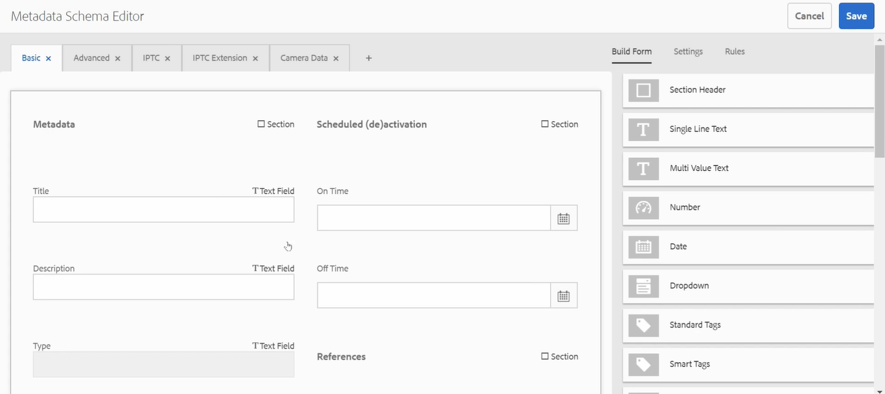

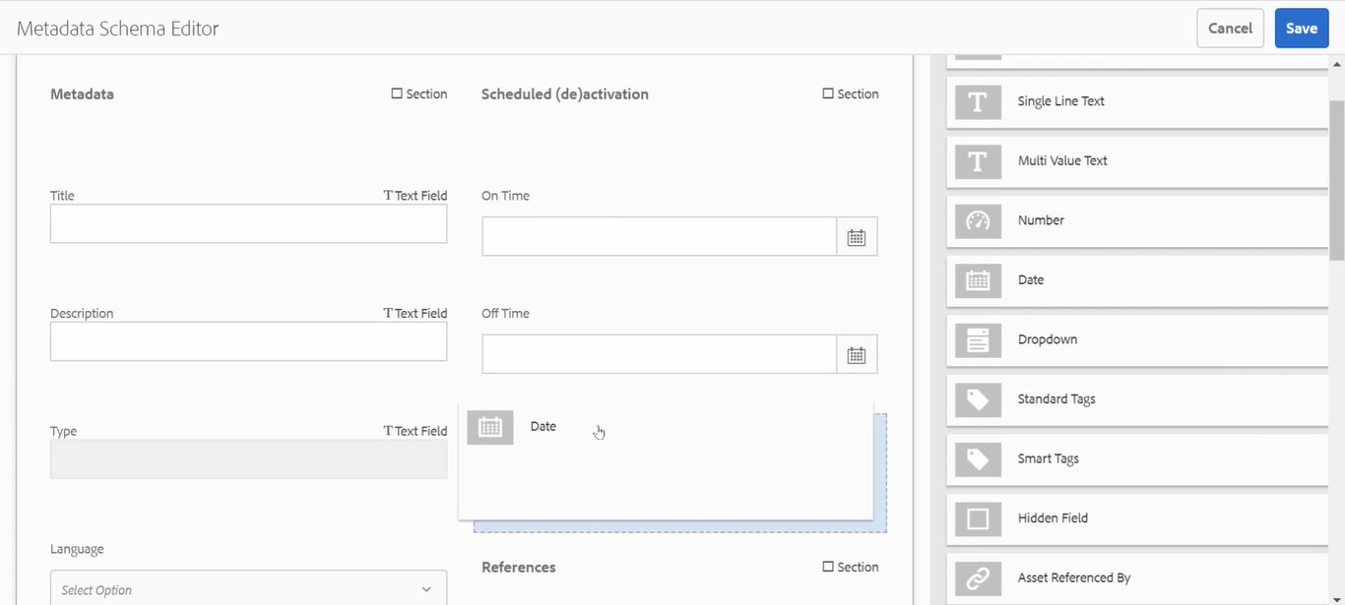

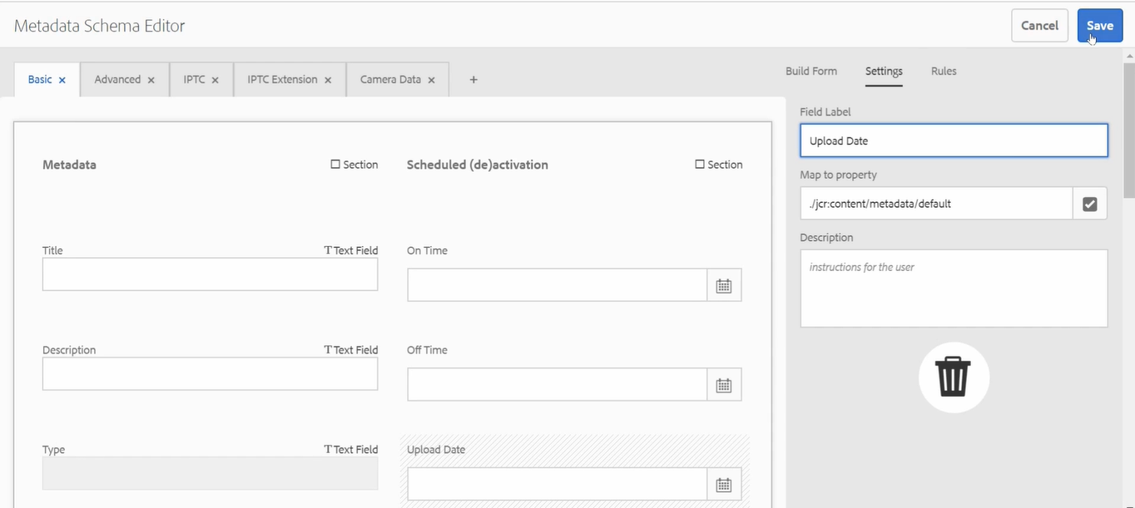

Now, **MySchema** is **ready** and to **apply** this to my **asset**.

Select **MySchema** schema -> **Click** on **Apply Folder** -> **Select** Folder -> **Apply**.

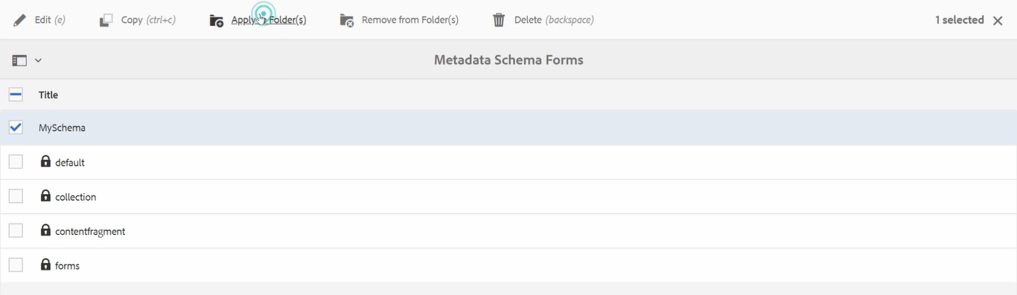

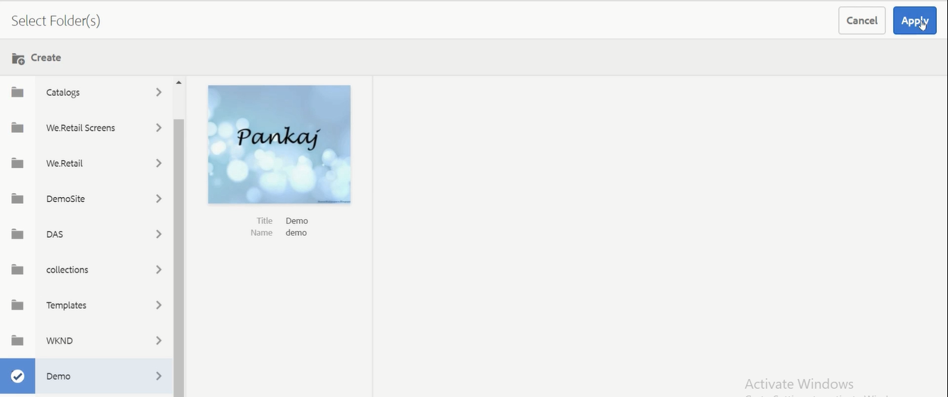

This way, you can **apply** the **Metadata** **Schema** to the **folder**.

Now go back to our image property from demo folder and you can see there “Upload data” is added

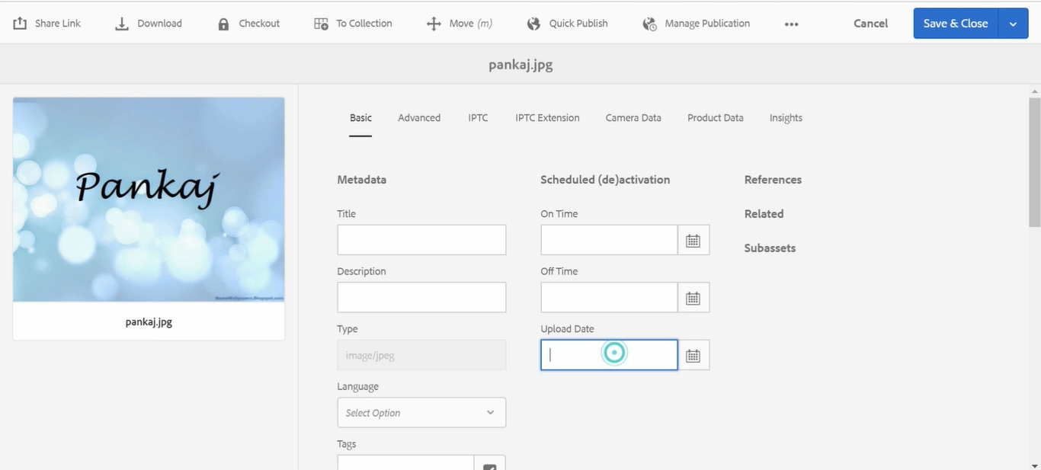

This way, you can **add** **extra property** using **Metadata Schema** to **AEM Assets**.

So, **Author** can put **Upload Date** and click on **Save & Close** button on Toolbar

To **Remove** the **Metadata Schema** from this folder, perform below steps

Select **myschema** --> Click **Remove from Folder** from Toolbar --> **Select** folder name(**demo**) --> **Remove**.

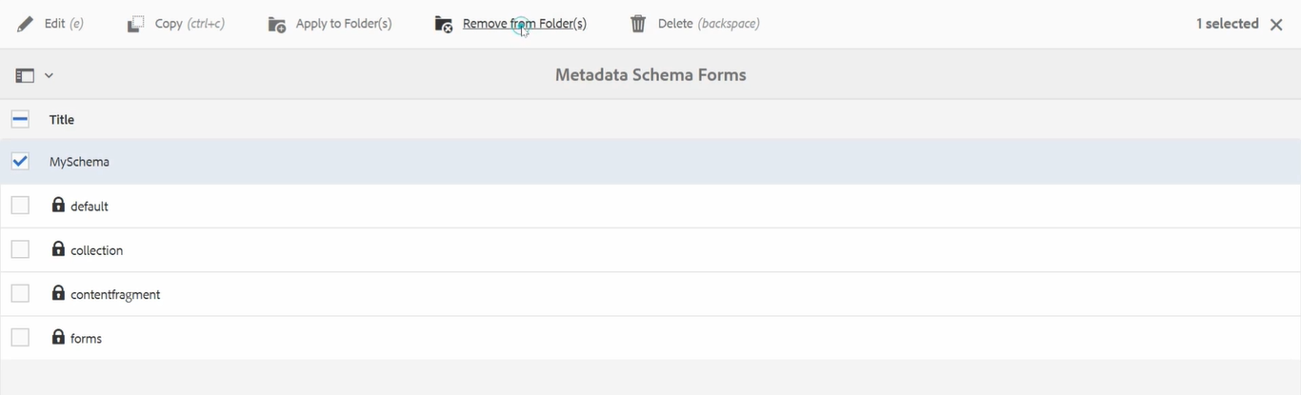

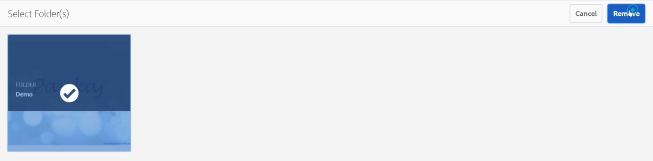

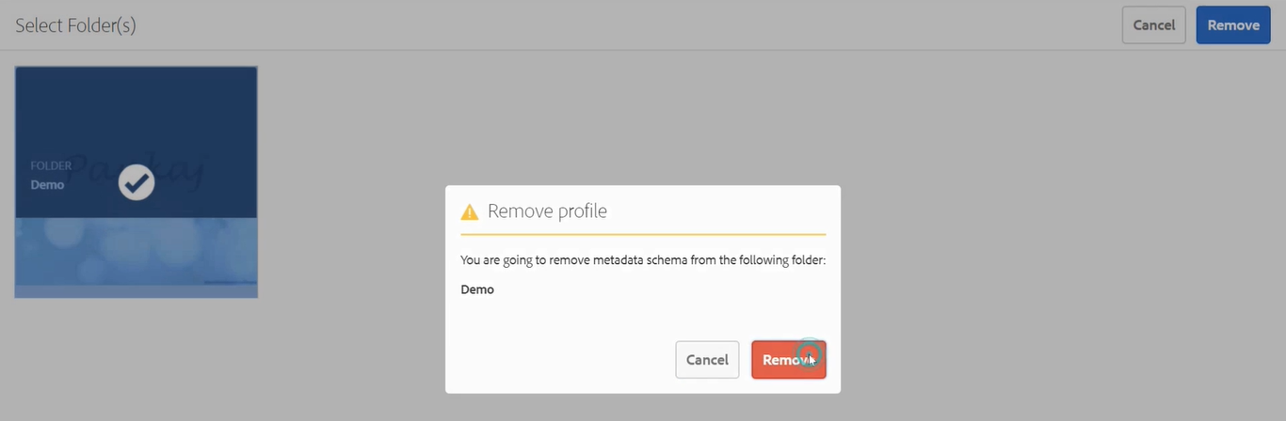

Once you **removed** the schema, you would **not** be able to see **Upload Date** metadata property.

This way, you can **add** **extra property** using **Metadata Schema** to **AEM Assets**.

# 88. CSV Asset Importer

**CSV Asset Importer** is a tool which is used to **import bulk of Assets and its metadata** into our **AEM DAM** using **CSV** **file**.

So **instead of importing** Assets and its associated metadata **manually** into AEM, you can use **CSV Asset** **Importer** tool to make your life easy.

**CSV Asset Importer** is very **powerful** and **flexible** in terms of use.

This tool is provided by **ACS AEM Tools.** Below is the real web site of **ACS AEM Tool**.

<https://adobe-consulting-services.github.io/acs-aem-tools/>

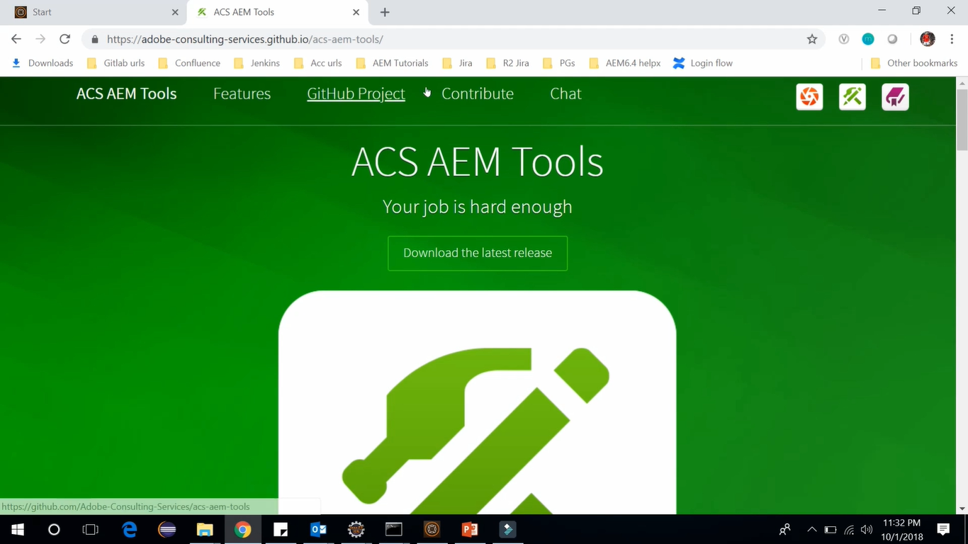

Download a package of **ACS AEM Tools** you can click on **Download the latest release** button from **ACS AEM Tool** official website (see above image).

On the next page, **click** on this **acs-aem-tools-content-1.0.zip** file. It will be downloaded.

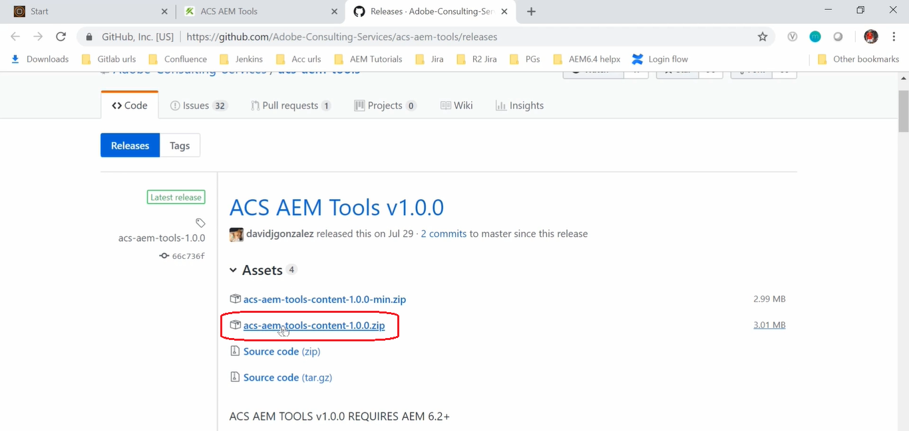

Go to the **CRX Package Manager** <http://localhost:4502/crx/packmgr>**.**

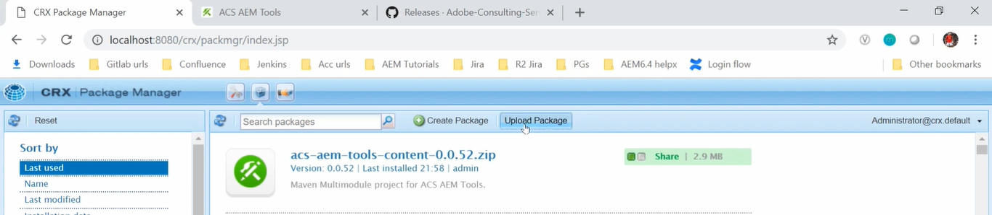

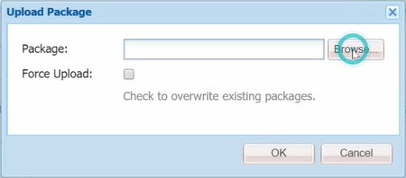

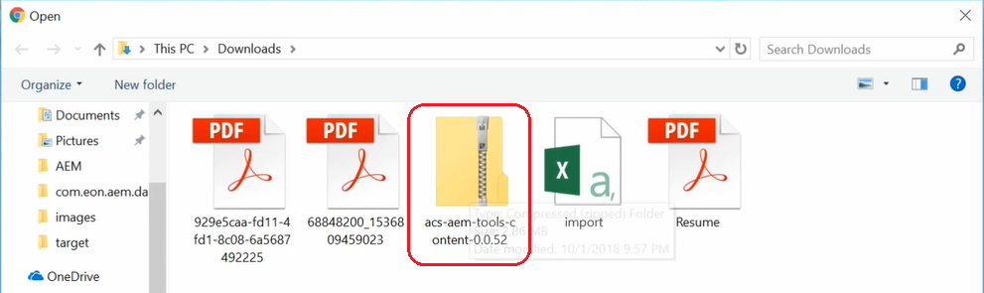

From package manager console, Click on **Upload Package** --> Click on Browse button --> Select the package

I**nstall** **ACS AEM Tools** package.

This way you can *download, upload and install* **ACS AEM Tools** package.

Go to official web site of **ACS AEM Tool** <https://adobe-consulting-services.github.io/acs-aem-tools/>

Click on **CSV Asset Importer** link-->Click on **Download an example CSV file** (to download sample CSV file)

//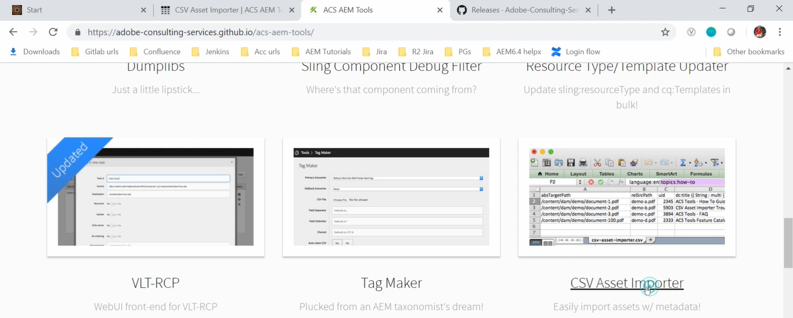

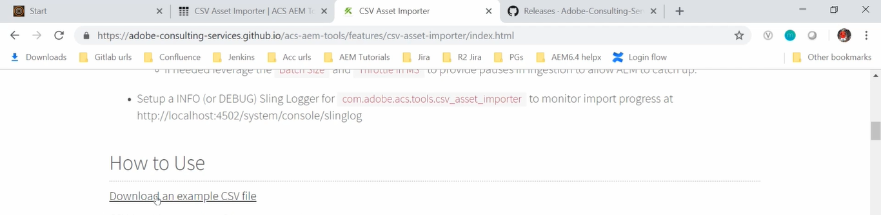

**Open** downloaded **sample CSV file** in Excel.

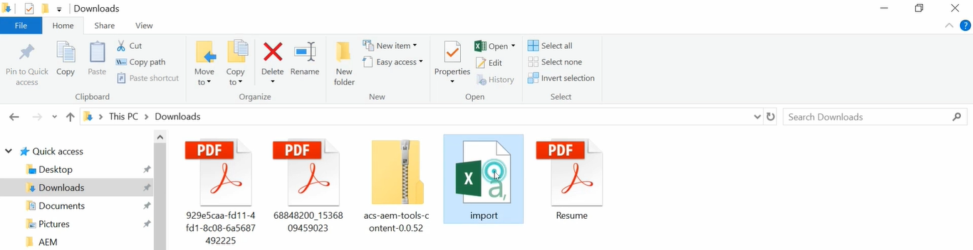

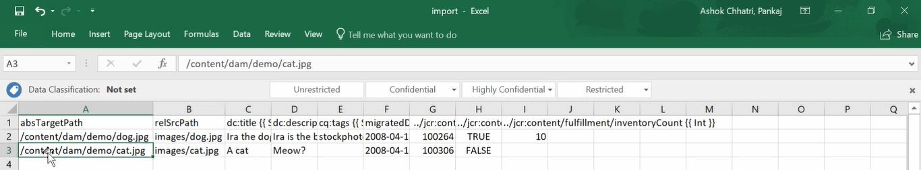

Above is the CSV file which we can import. Every row in this file represents an asset.

1st column represents **absolute target path** which is the AEM location *where this asset will be imported*.

2nd column represents **relative source path** which is the relative path to the file in jest.

So, our assets will be uploaded in the **/content/dam/demo** folder (see 1st column) and the path from which I want to *import the asset* is within the **images/dog.jpg** and **images/cat.jpg** (see 2nd column)

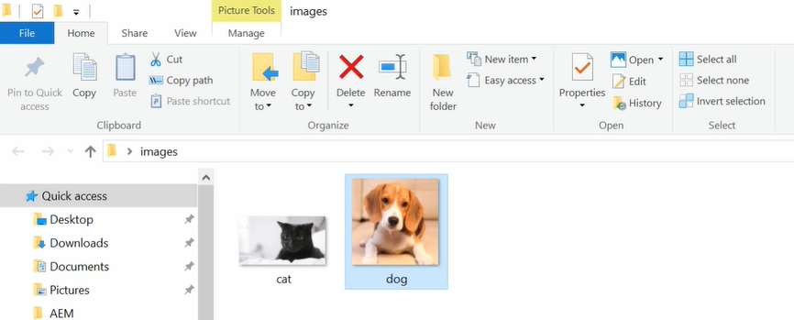

We have the assets (cat.jpg and dog.jpg) within images folder. Similarly, you can have assets in bulk.

Within **CSV file**, we also have the **other metadata** such as **title**, **description**, **tags** and other information.

Go to the **AEM instance** --> click on **Tools** --> click on **CSV Asset Importer**

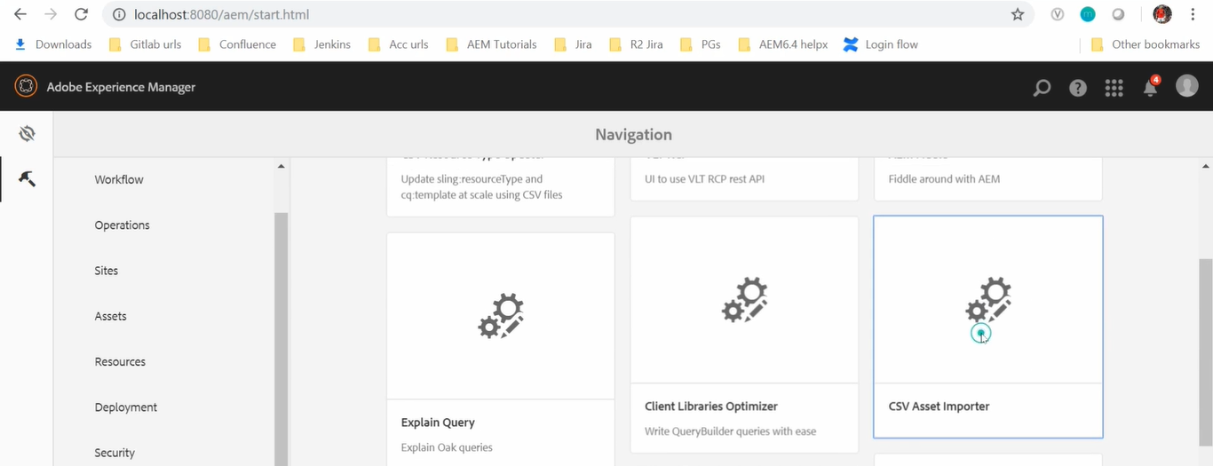

It will open **CSV Asset Importer Console**. Here we have *option of selecting* **a CSV file.**

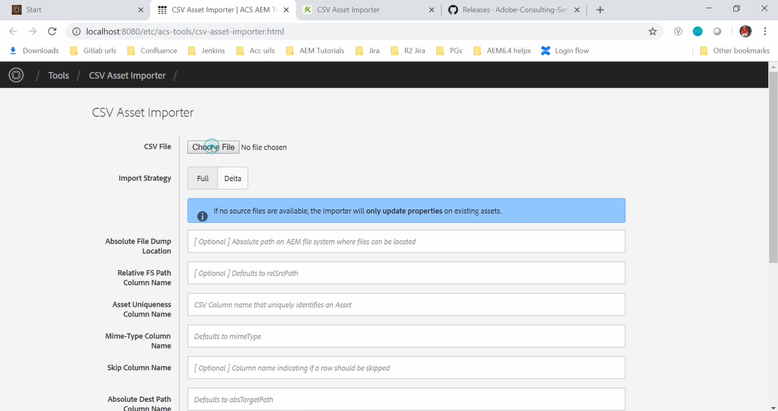

In this **CSV Asset Importer Console** --> Click on **Choose File** button --> **Choose** the file -->



There are two **Import Strategy**

1. **Full** (default)

It will upload all the assets mentioned in CSV.

1. **Delta**

It will update only fields/properties of already uploaded assets (existing assets)

Set below properties

|  |  |
| --- | --- |
| **Field Name** | **Field Value** |
| Import Strategy | Full |
| Absolute File Dump Location | C:\Desktop (full path of our Asset) |

**Click** on **Import Assets** button.

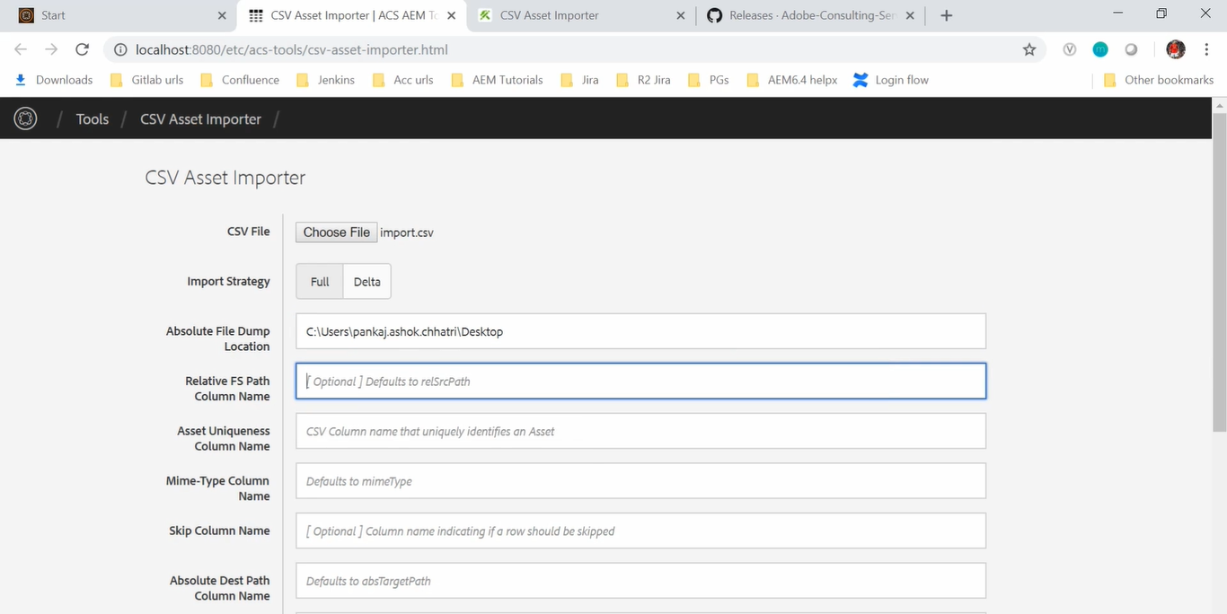

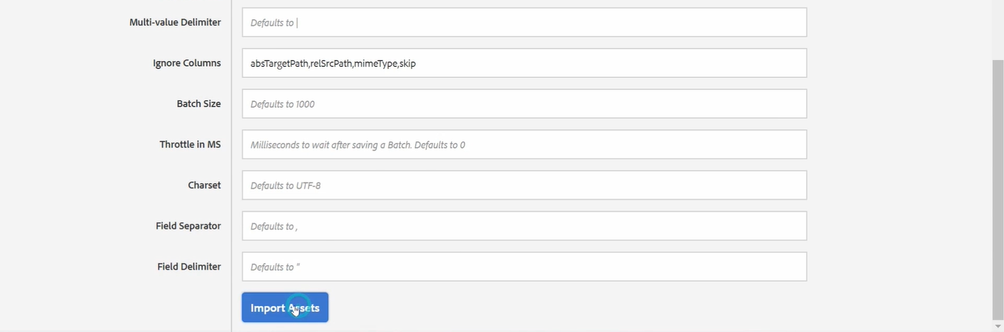

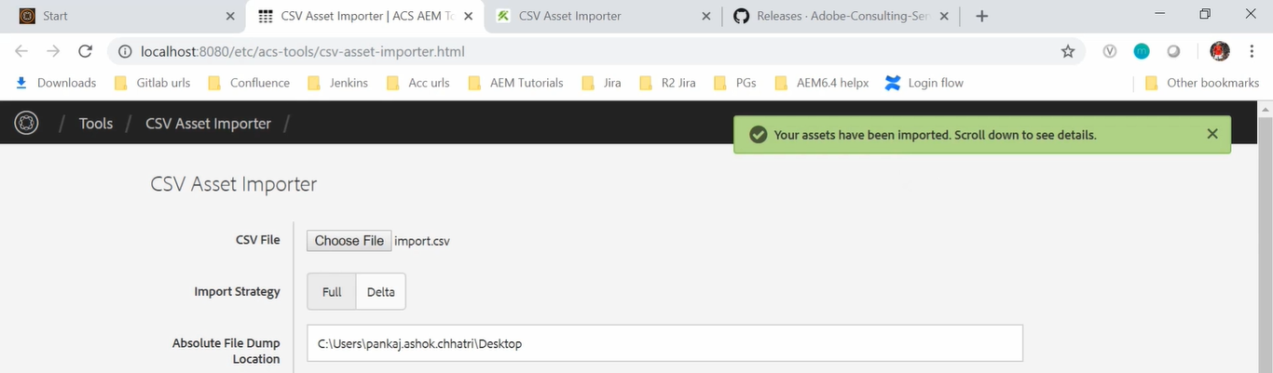

Go to **AEM** -> **Assets** --> **Files** --> **Demo** folder

Here you can see the cat and this dog image has been uploaded.

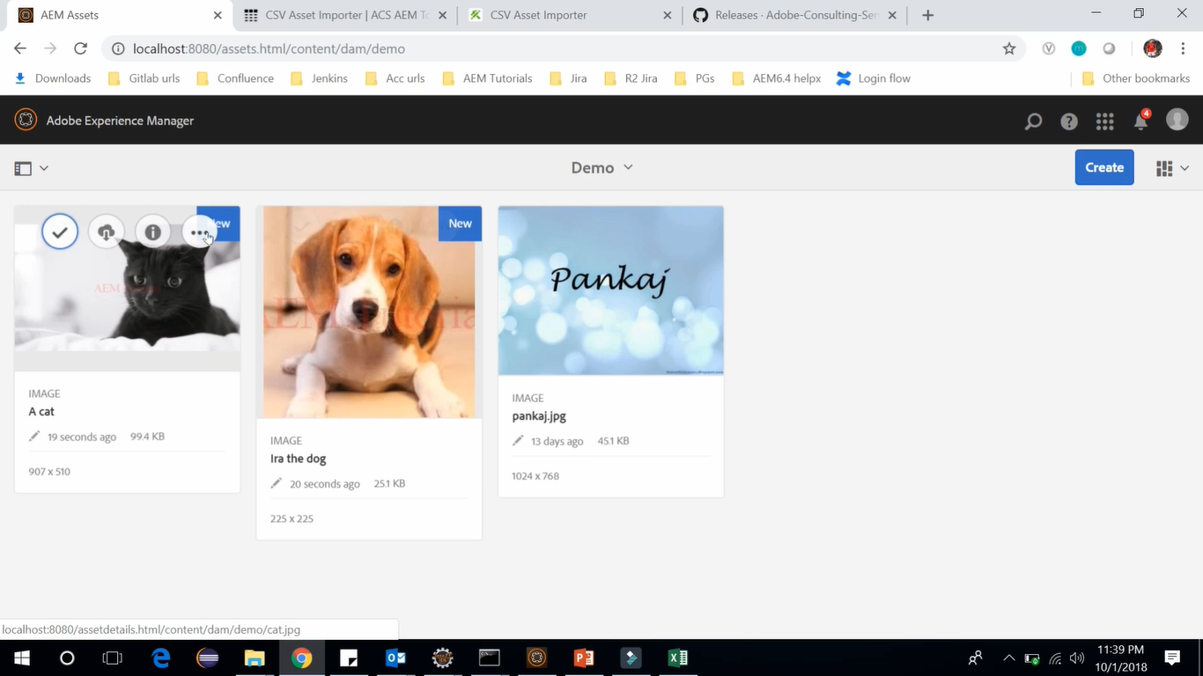

We can see that **New** text on the right upper corner of the images.

Select **Cat** image --> Click on **Properties**

We should be able to see image and its associated metadata such as Title, Description and Created Date

which was available in CSV file.

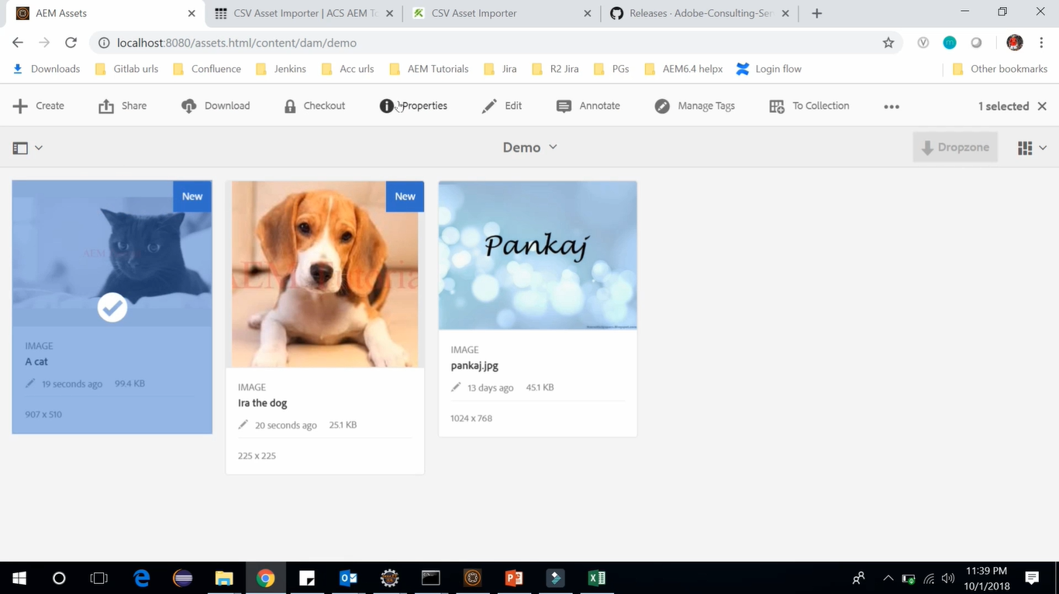

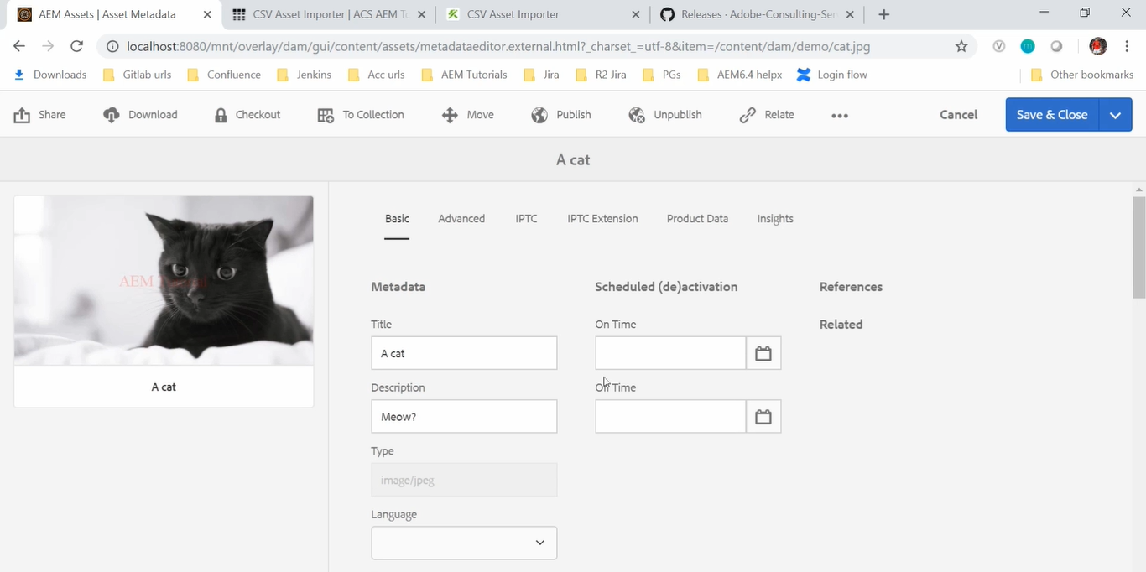

This way you can **import** the *assets in bulk* using **CSV import facility** provided by **ACS AEM Tools**.

# 89. Annotating pages

In this section, we will discuss about Annotating pages in AEM.

When you work inside AEM, chances are that other team members and other authors are also working.

Adobe has built *several features* that allow your **team** to **collaborate**. One of the features is **Annotation**.

using this **Annotation** feature, one author adds content to a page which can be subject to a discussion with other team members prior to publishing.

**Annotation** solves the problem of page specific information flow, allowing you to leave messages or comments for other authors within the context of the page.

So, let’s have a look *how annotation works* in AEM pages.

**AEM** --> **Sites** --> **We Retail** site --> Select **United States** --> select **English** page --> click **Edit** on Toolbar

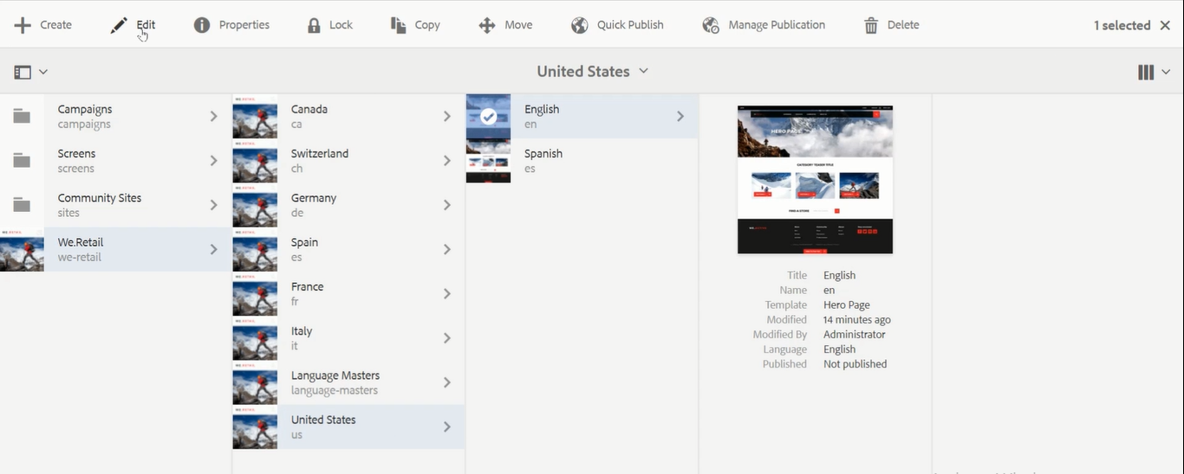

In this page you can see an **icon** *with the plus sign* at rightmost corner on Toolbar. Click on it.

It allows author to enter the Annotate mode.

Using these annotations, you can leave comments on different components.

*Follow below steps* to **add comment** on the *image* which should be *visible to other authors*.

**Click** on the **icon** with *Plus sign* (Top left corner) named **Add annotation** --> **click** on the **image** *where you want to* *add comment*. *(follow the images below)*

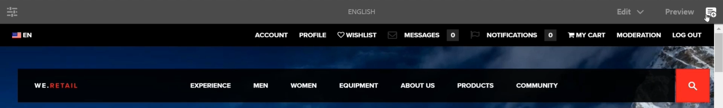

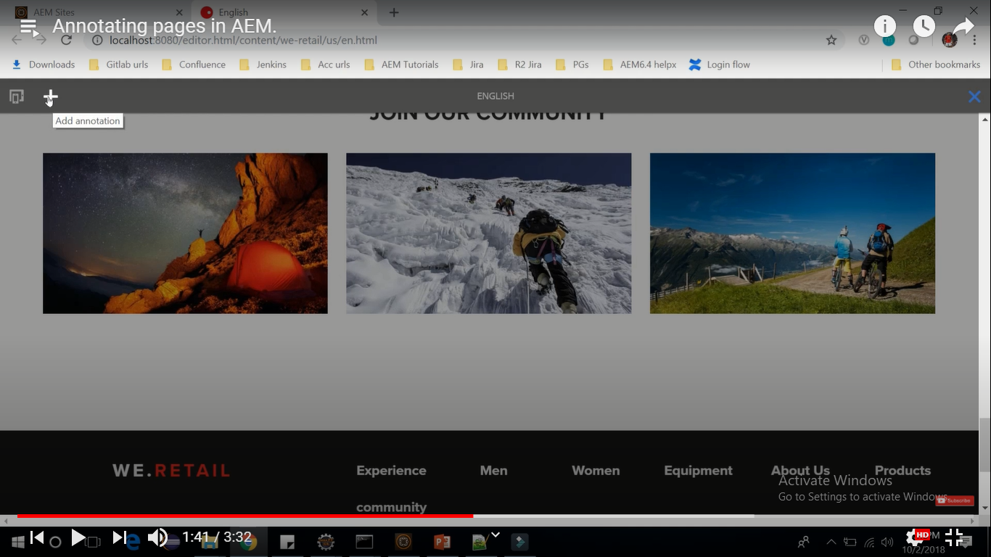

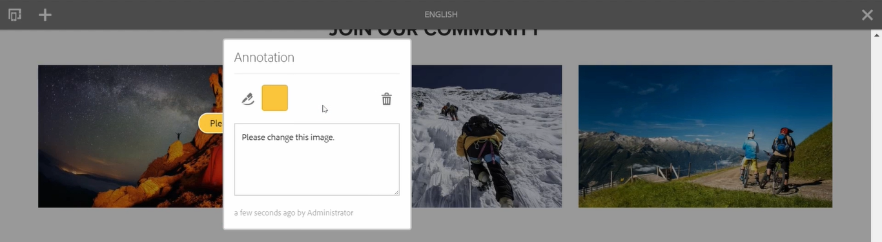

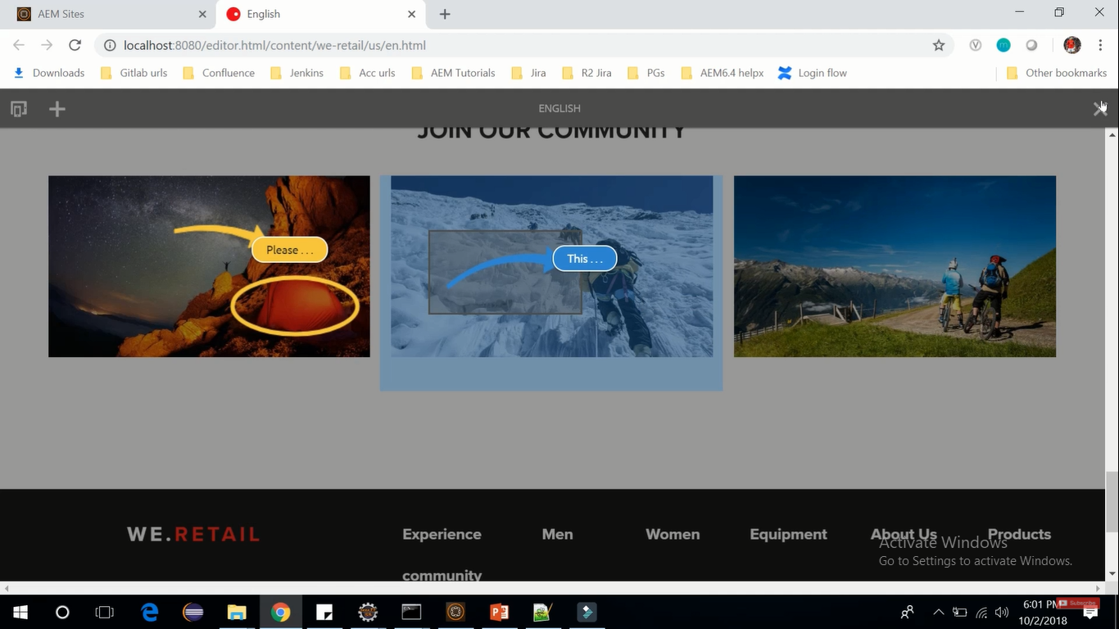

Write the **comment**, select **color** of the comment and **shapes** like arrow or circle on multiple images.

Once done with comments, come out of this using cross sign from right (cursor pointer from above image).

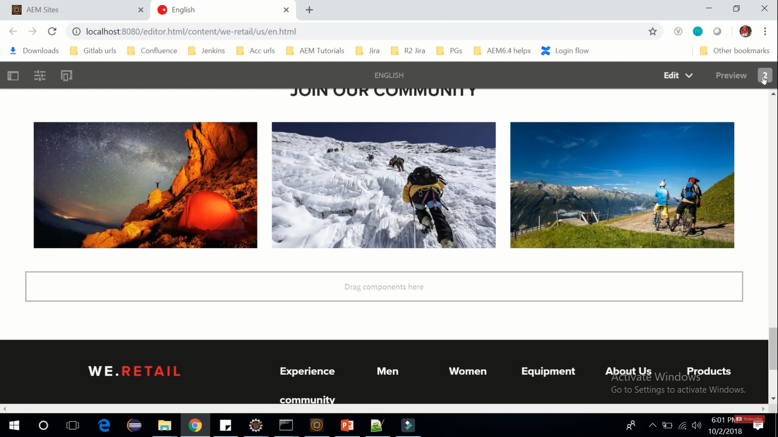

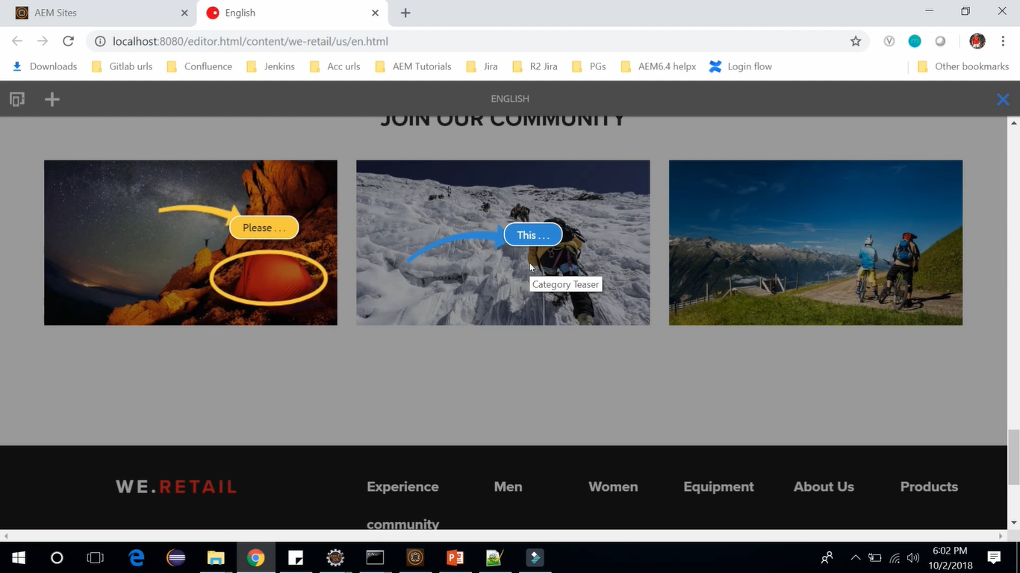

On right top of the page, we can see 2 annotations and on clicking that again it will show the comments.

To **delete** any **Annotation**, follow below steps:

**Double click** on Annotation --> Click on **Delete Annotation** icon on *Annotation dialog box* --> Click **Delete** on *Confirmation dialog box*.

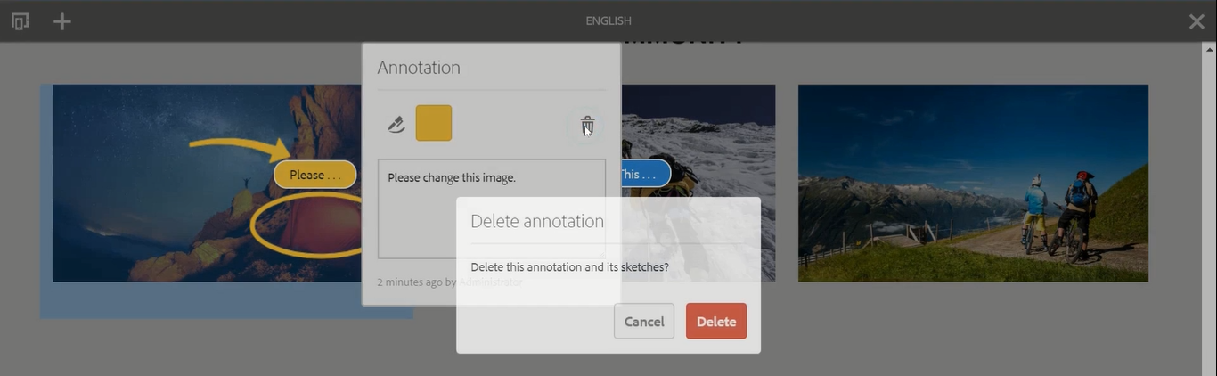

# 90. Download AEM 6.4 feature pack 2

Adobe has recently released **AEM 6.4 feature pack 2** which comes with a *new feature* which is called **SPA editor** and this SP editor is a recommended solution for the projects which are using **SPA framework-based client rendering**. For example, the **React Js** or **Angular Js**.

**SPA** means **Single Page Application**.

So, in that case it is **beneficial to use** *SPA editor feature* which comes with *feature pack 2*.

So, in this section we will see how to **download** and **install** *SPA feature pack 2* of *AEM 6.4*.

Go to below mentioned link.

<https://experienceleague.adobe.com/docs/experience-manager-64/release-notes/sp-release-notes.html?lang=en>

Click on **URL** mentioned in the **Download URL** field named *AEM 6.4.2.0 on PackageShare*.

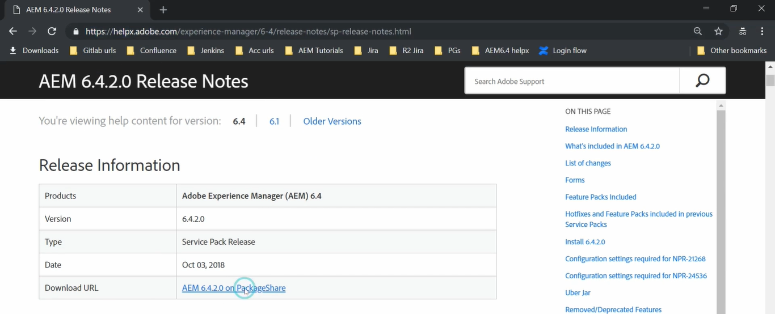

It will take you to the AdobeAEMCloud.com. Here you need to sign in using your Adobe ID.

Click on **Sign In** button and provide your **username** (i.e. Adobe ID) and **password**. Click on **Sign In** button.

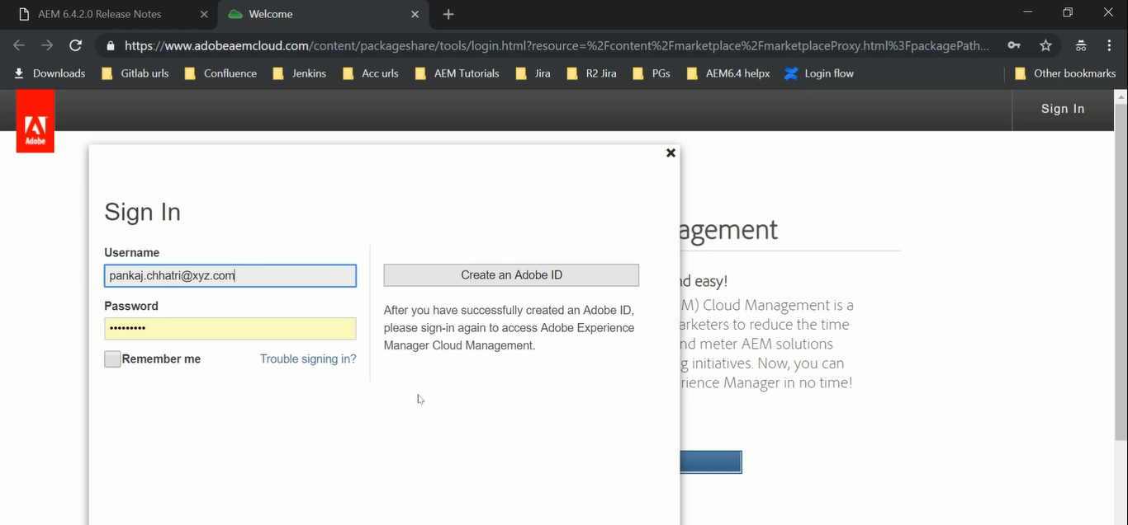

It will take us to page (image below) where we will find ***AEM 6.4.2.0*** (which is the *feature pack 2)*.

Click on **Assets** tab -->Click on the link to **download** the package --> **Agree** checkbox-> **Accept** button.

After that it will start downloading.

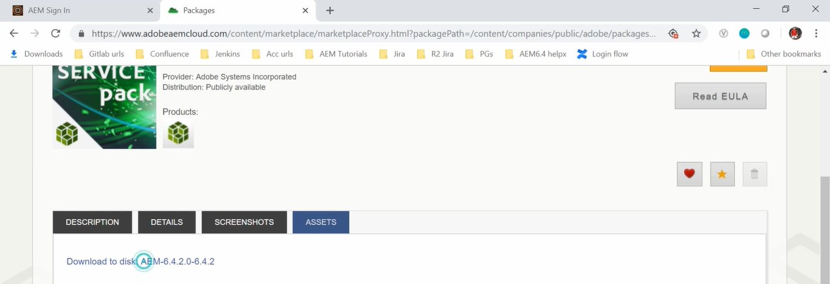

Once downloaded, go to AEM 6.4 --> **CRX Package Manager** <http://localhost:4502/crx/packmgr>**.**

**Upload Package** which we downloaded just now.

Click on **Browse** --> **Select** your *package* which you have *downloaded* --> Select force upload --> **OK** button.

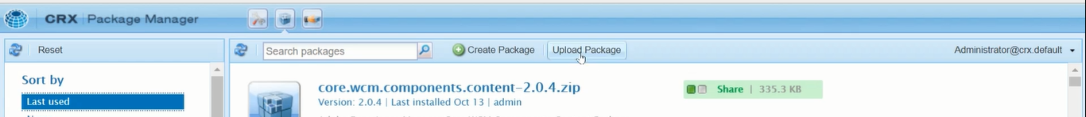

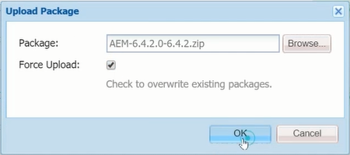

Once uploaded, just click on install, it will start installing, and finish imported successfully.

Now you can click on refresh because it has been installed. Once you will refresh you can see the package here aem-service-pkg-6.4.2.

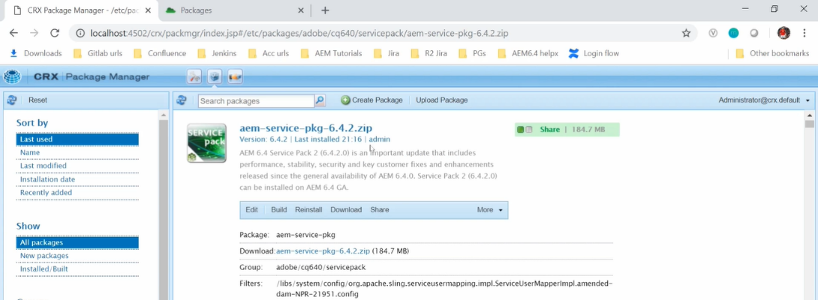

# 91. TouchUI Multifield Component – Part 1

**What is TouchUI multi-field component?**

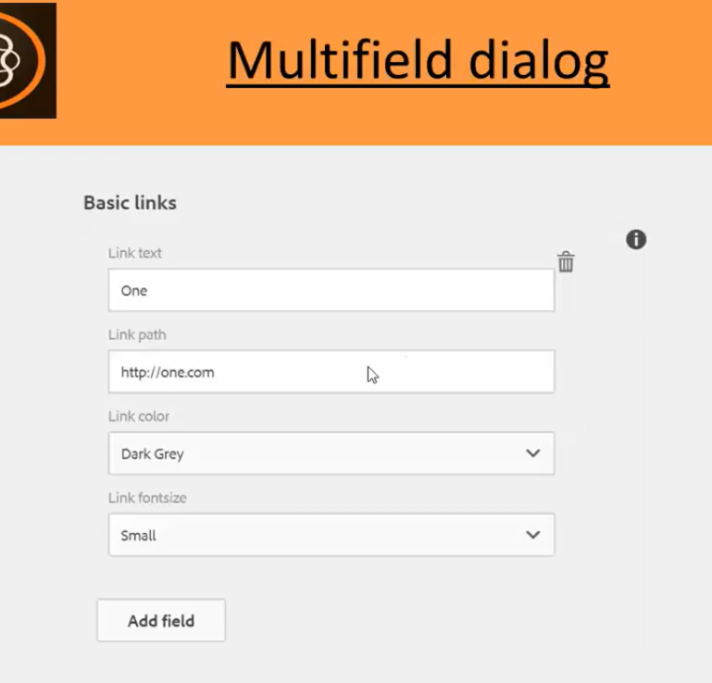

Above shown is the Multifield.

Multifield has group of fields (Link Text, Link path and Link color and Link font size, etc)

Consider a scenario where you need navigation tab where you can have multiple links.

So, it will have the Link Name, Link path etc.

If you have 3 links so you will define total six fields. Text fields and path browse for each link for 3 times.

It is a kind of static and not dynamic. If you want to delete something, then you cannot do that.

That is the reason why we need **Multi-field** component. So that you can add or delete it dynamically.

To **add** other fields, you can click on **Add field** button and you will get the same appearance of these fields to enter details of next link inputs. This way you can delete and add more fields

Actually, out-of-the-box (built-in) Multi-field component has some **limitations**. Because of which, we will use **ACS Common package**.

**ACS** stands for **Adobe Consulting Services.** It is an **open source project** hosted on **GitHub.**

It **enhances** the existing **Multi-field component** and makes it **easy to use.**

So let's first download the easiest

Download the ACS Commons package (version 3.17.X) from the link

<https://github.com/Adobe-Consulting-Services/acs-aem-commons/releases>

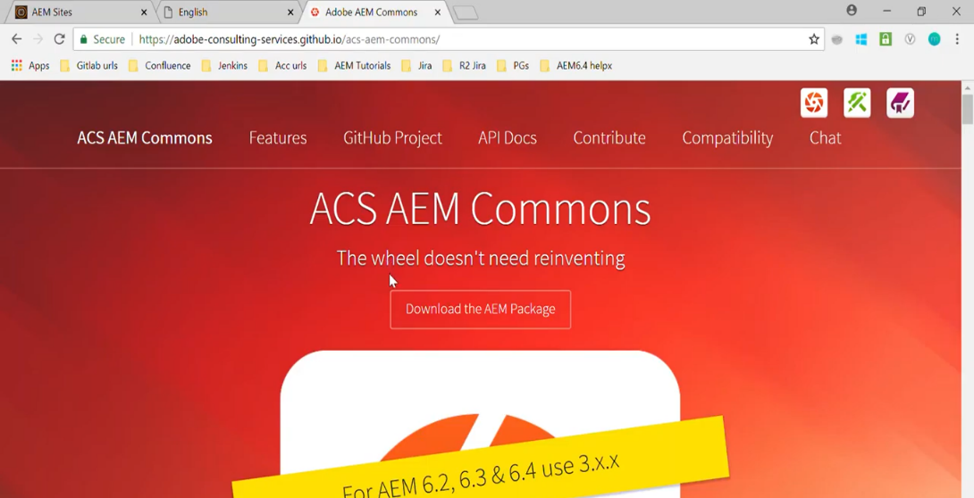

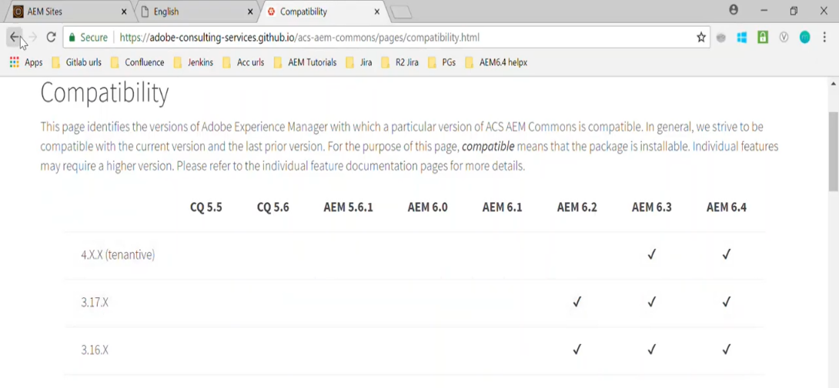

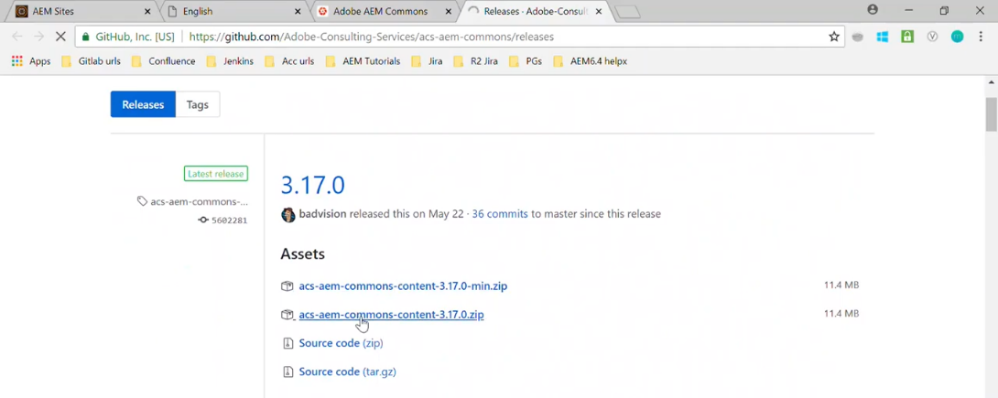

Once download is completed for ACS commons 3.17, go to CRX package manager and upload this package.

Go to <http://locahost:4504/CRX/packmgr> --> Click **Upload Package** button --> select downloaded ZIP --> Click **OK** button --> Click **Install** link (for uploaded package)

Once package is uploaded and installed, go to CRX/DE path **/apps/training/templates**

Right click on **/apps/training/templates** node --> **Create** --> **Create Template** --> Assign below **properties**

Click on **Next** --> Click on **OK** --> Click on **Save All**

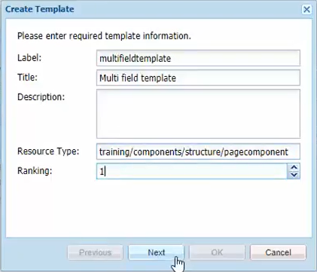 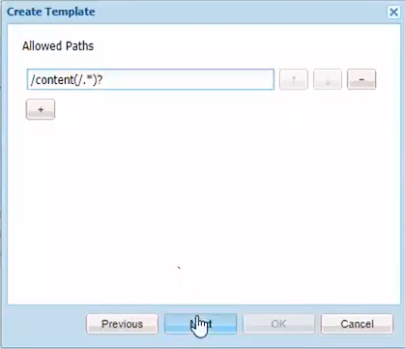 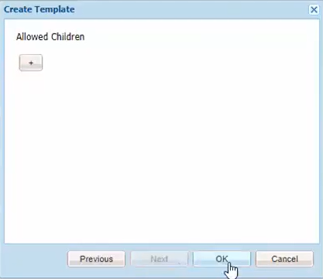

This so we have created a template now we will create the page rendering component within node **/apps/training/components/structure** and we will name it as **pagecomponent.**

Right click on **/apps/training/components/structure** node --> **Create** --> **Create Component** --> **Set below**

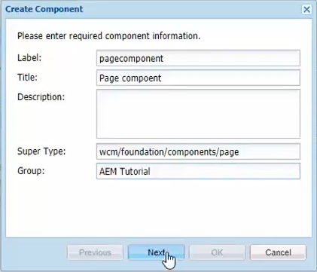

Click on **Next** button --> Click on **OK** button --> We have **created** our page component successfully.

Rename **/apps/training/components/structure/pagecomponent/pagecomponent.jsp to pagecomponent.html** --> **Delete** its **file contents --> Copy** from below **URL** and **Paste** in this file

Go to <https://github.com/pankajchhatri/AEM> --> [Developer course](https://github.com/pankajchhatri/AEM/tree/master/Developer%20course) --> [Chapter 10 Authoring Structure Components](https://github.com/pankajchhatri/AEM/tree/master/Developer%20course/Chapter%2010%20Authoring%20Structure%20Components) --> [Lab Activity - VI](https://github.com/pankajchhatri/AEM/tree/master/Developer%20course/Chapter%2010%20Authoring%20Structure%20Components/Lab%20Activity%20-%20VI) --> [multifieldpage](https://github.com/pankajchhatri/AEM/blob/master/Developer%20course/Chapter%2010%20Authoring%20Structure%20Components/Lab%20Activity%20-%20VI/multifieldpage)

<sly data-sly-include="/libs/wcm/core/components/init/init.jsp" data-sly-unwrap/>

<div data-sly-resource="${'content' @ resourceType='foundation/components/parsys'}" ></div>

This code is **very simple**. We are having a **Parsys** and this is a **init.jsp.** This component will have only *Parsys*.

Click on **Save All** button.

In this **Parsys** I will drag and drop my component which will have the multi field dialog.

So to create a page, go to Site console <http://localhost:4502/sites.html/content> --> **Create** --> **Page**

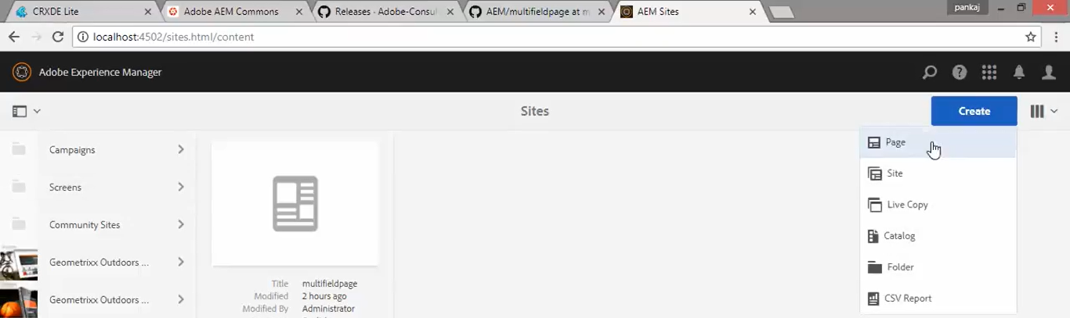

Select **Multi field template** --> Click on **Next** button on Toolbar --> Set below **Properties** --> Click on **Create** This will create our page. Click on **Open** button.

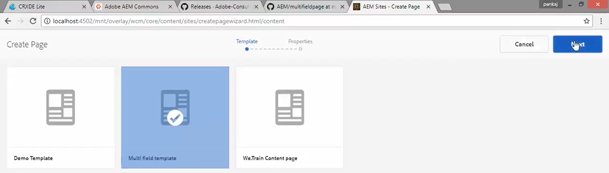

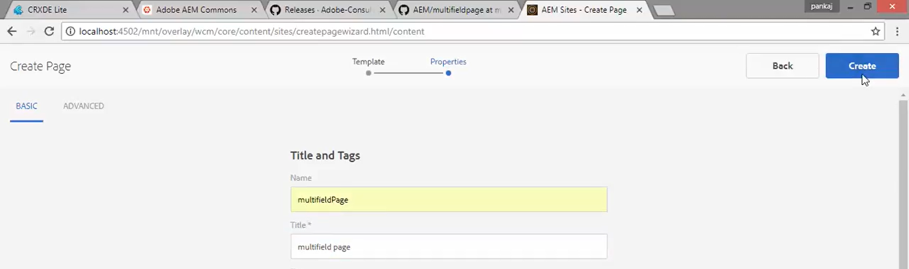

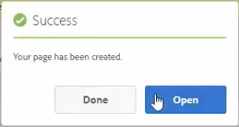

We can see Parsys (in below image). So, the plot is set. We got Template and Page Rendering Component.

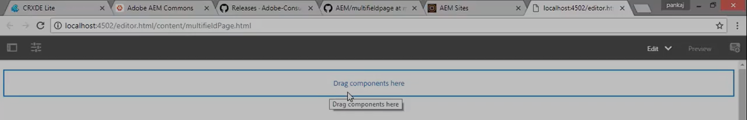

# 92. TouchUI Multifield Component – Part 2

In earlier section (Part 1), we installed **ACS Commons Library** and then we created a **Template** and a **Page Rendering Component** for that.

In this section (Part 2), we will create a content component which will have the multifield dialog.

Right click on CRX/DE node **/apps/training/component/content** --> **Create** --> **Create Component** --> Assign below **field values** -->Clickon **OK** button --> Click on **Save All** button

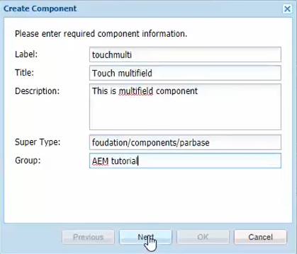

Rename newly generated component’s JSP file . **/apps/training/component/content/touchmulti/touchmulti.jsp** to **touchmulti.html**

**Replace** contents of this file with below new code.

<h1> This is the multifield component </h1>

Right click on **/apps/training/component/content/touchmulti** node --> **Create** --> **Create Node** -->

Assign below **field values** -->Clickon **OK** button --> Click on **Save All** button

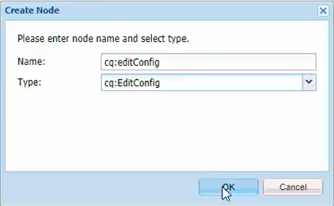

We need this newly created node **cq:editConfig**, so that our component will be editable, and it will be available inside **Side Rail** or **Side Kick** **(Component Browser)**.

Now our component is ready. Let’s Open the page.

Go to **AEM** --> **Sites** --> **multifield** page --> Click on **Edit** icon on Toolbar --> multifield Page will open --> Click on **Design Mode** on Toolbar to go to Design Mode --> **Enable** the component using below steps --> Click on **Drag components here** section --> Click on the **Configure** icon --> The **Edit Dialog** box will open --> In ParSys (Design) tab expand AEM Tutorial (group name ) node --> Check **Touch multifield** checkbox --> Click on **OK** button

Open **Page** again in **Edit** mode --> Double click on **Drag components here** section --> Select **Touch Multifield** component to Insert the Component on the Page.

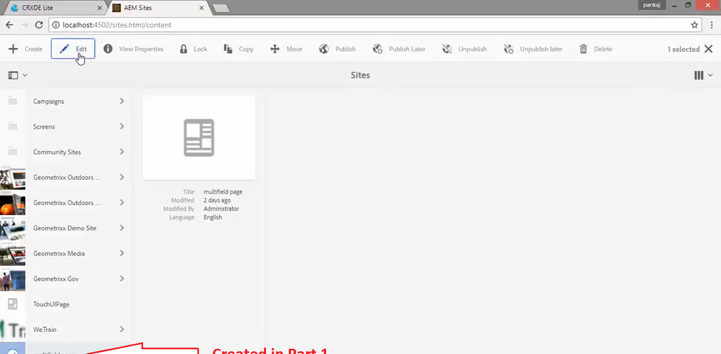

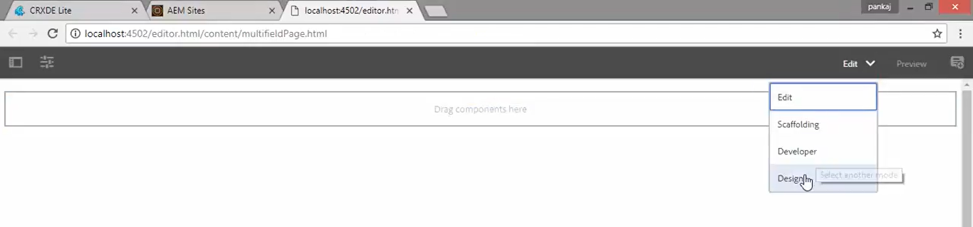

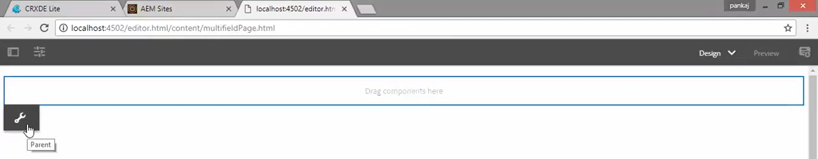

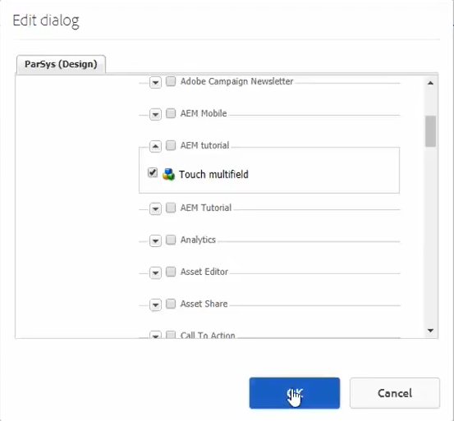

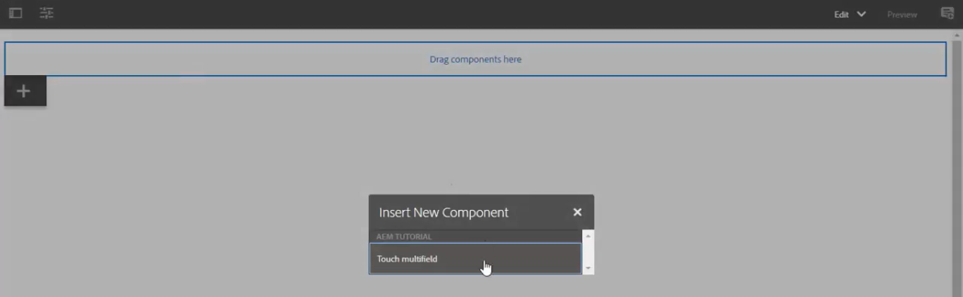

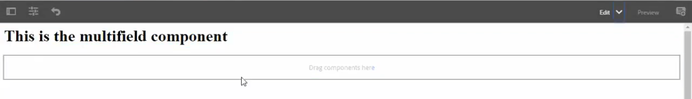

Now the component has been **displayed** on the page. Now we will **create** the **Dialog**.

In below image, see **cq: dialog** node. That is our diaog box. See the video to create entire node hierarchy.

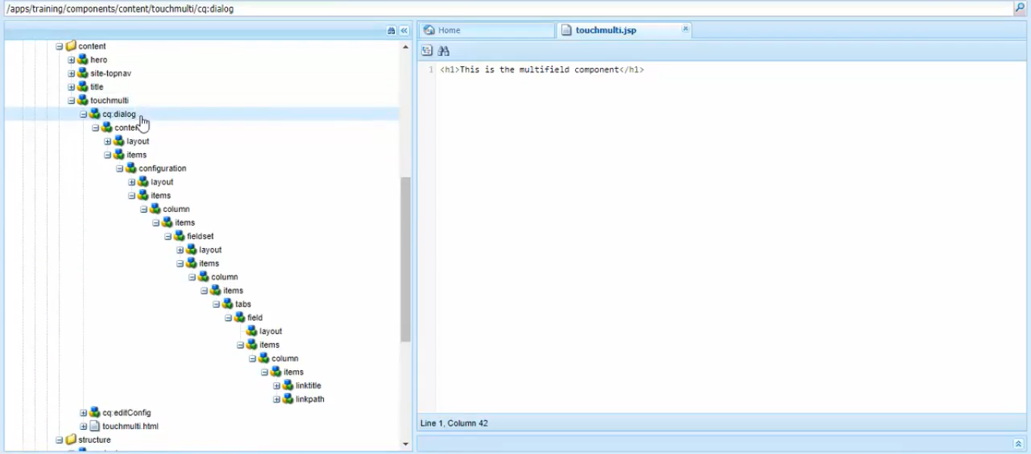

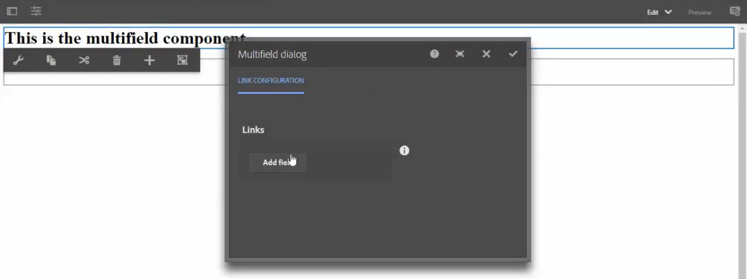

Go back to the **page** --> Double click on the **component** --> Above shown dialog will open --> This is multifield dialog

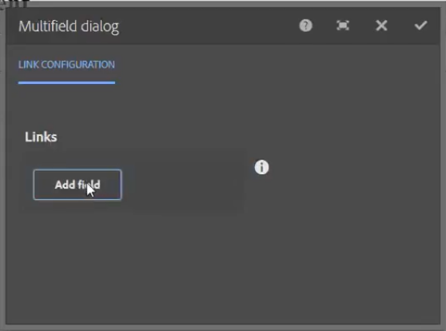 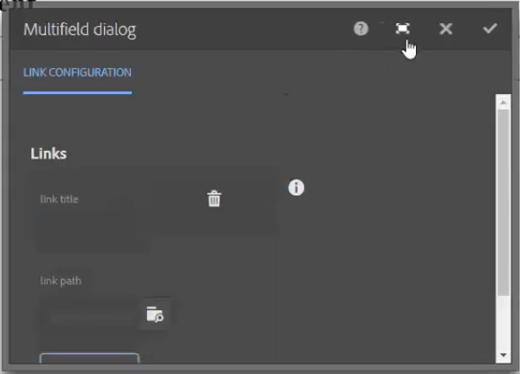

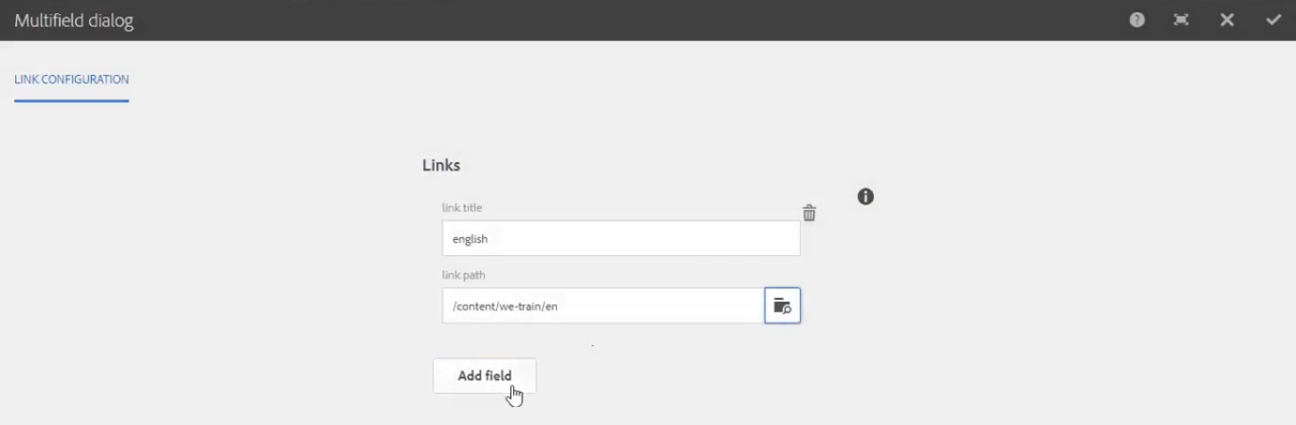

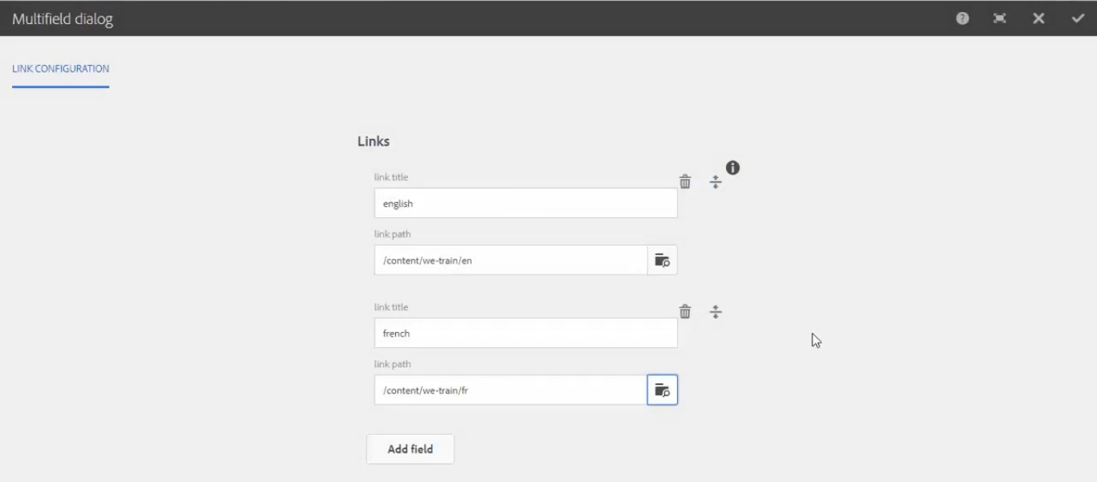

This way, you can **Add** multiple fields and you can also **Delete** or **Reposition** the fields.

You can see your entered fields in the form of JSON format on **linkmultifield** property of CRX/DE node

**/content/multifieldpage/jcr:content/content/touchmulti** (follow below images)

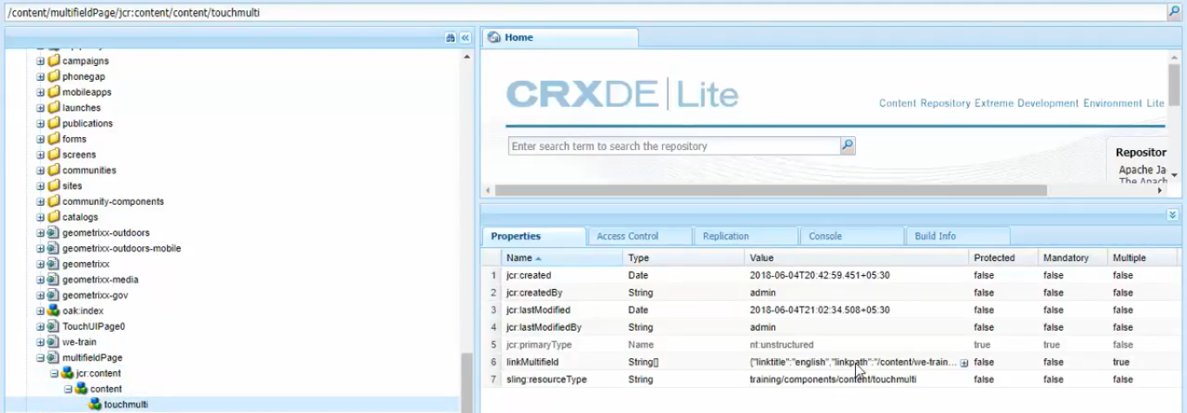

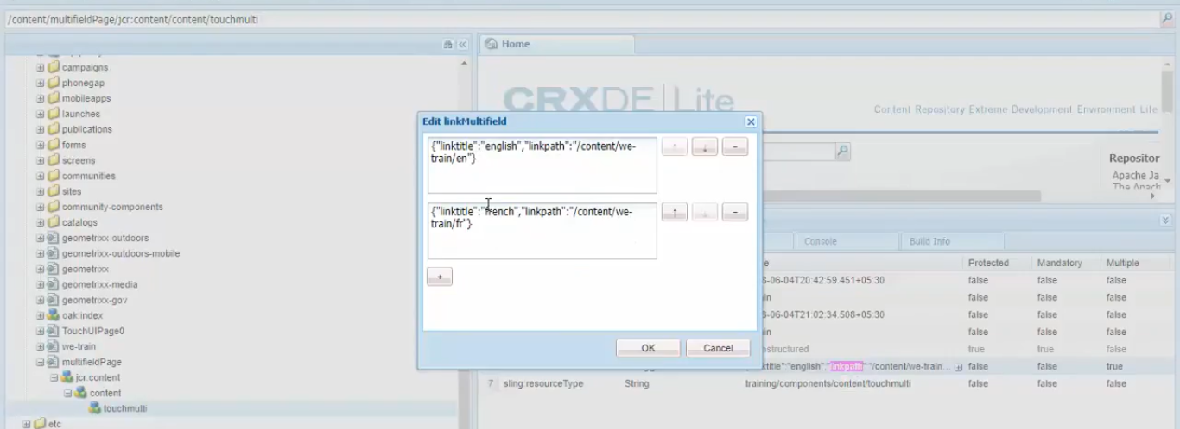

# 93. TouchUI Multifield Component – Part 3

In last section, we created the Multifield Component and we also created Multifield dialog.

In this section, we will see how we can **read** the *Values* and to **show** those *Values* in your page.

Go to <http://localhost:4502/editor.html/content/multifieldpage.html>

*Double click* on **Multifield component** to open **Multifield dialog.**

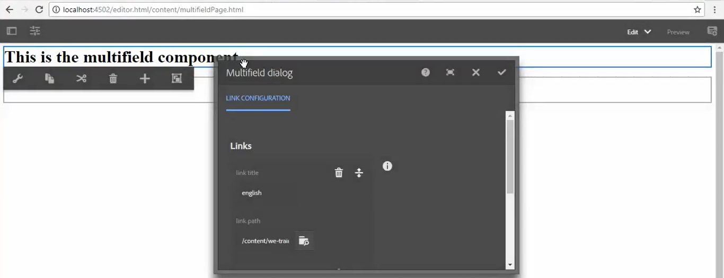

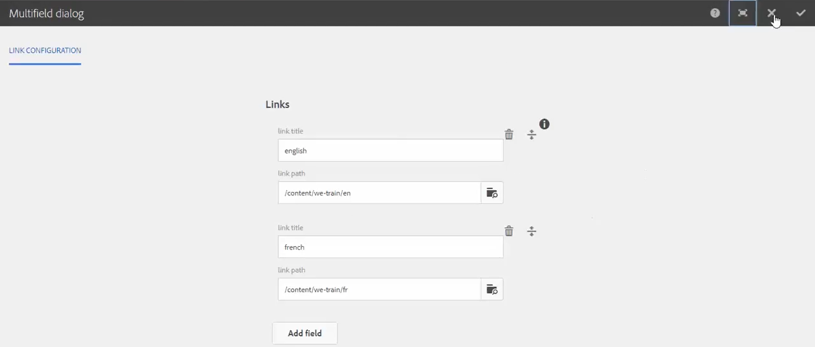

**/content/multifieldPage/jcr:content/content/touchmulti** CRX/DE node is our **Page**. **linkMultifield** is JSON.

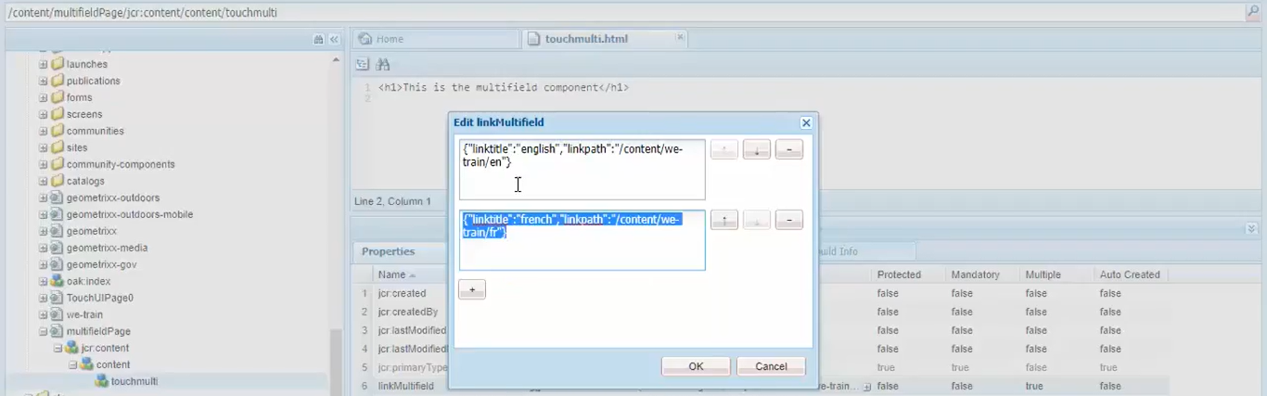

This is how Multifield **data** is getting stored in the form of JSON.

**Right click** on **/apps/training/components/content/touchmulti** --> **Create** --> Create **File** --> **touchmulti.js**

We can **read** *Multifield values* in 2 ways:

1. WCM POJO
2. API of JavaScript

In this demo, we are using API of JavaScript.

**Copy code** from below **URL** and **Paste** in this newly created **touchmulti.js** file --> Click on **Save All** button.

Go to <https://github.com/pankajchhatri/AEM> --> [Developer course](https://github.com/pankajchhatri/AEM/tree/master/Developer%20course) --> [Chapter 10 Authoring Structure Components](https://github.com/pankajchhatri/AEM/tree/master/Developer%20course/Chapter%2010%20Authoring%20Structure%20Components) --> [Lab Activity - VI](https://github.com/pankajchhatri/AEM/tree/master/Developer%20course/Chapter%2010%20Authoring%20Structure%20Components/Lab%20Activity%20-%20VI) --> [multifield](https://github.com/pankajchhatri/AEM/blob/master/Developer%20course/Chapter%2010%20Authoring%20Structure%20Components/Lab%20Activity%20-%20VI/multifield)

use(function () {

var linksList = [];

var linkArray = properties.get("linkMultifield");

if(linkArray != null){

for(var i = 0; i < linkArray.length; i++) {

var singleObj = {};

var itemObject = JSON.parse(linkArray[i]);

singleObj['title'] = itemObject.linktitle;

singleObj['path'] = itemObject.linkpath;

linksList.push(singleObj);

};

}

return {

linksList: linksList

};

});

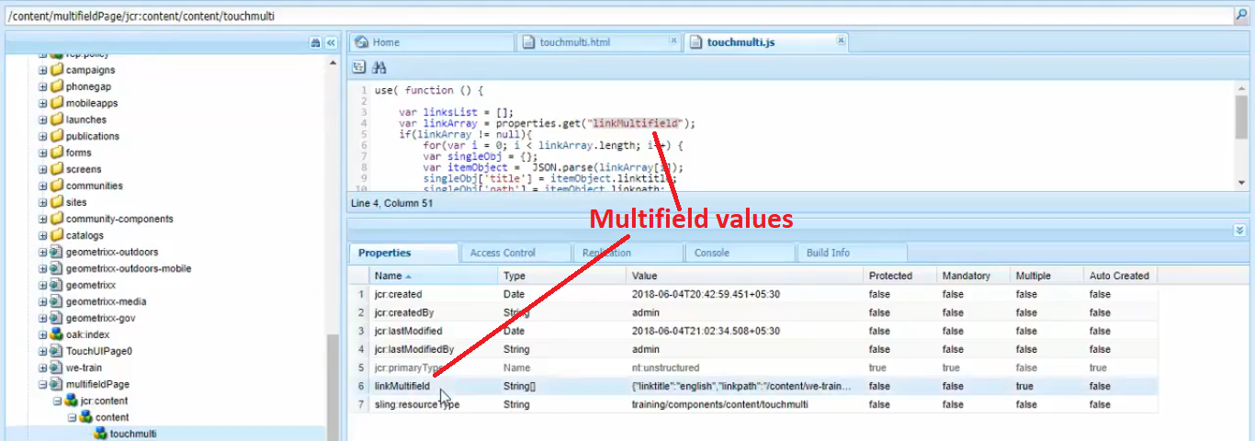

Line number 4 is where we are fetching Multifield values from using our property named **linkMultifield**.

There we are **looping** through each of these Multifield values to fetch each Link’s **Title** and **Path** and then return such complex object **linksList**.

Now we need to read this **linksList** object and show values in our HTML file.

Go to component’s HTML file on path **/apps/training/components/content/touchmulti/ touchmulti.html**

**Copy code** from below **URL** and **Paste** in this **touchmulti.html** file --> Click on **Save All** button.

Go to <https://github.com/pankajchhatri/AEM> --> [Developer course](https://github.com/pankajchhatri/AEM/tree/master/Developer%20course) --> [Chapter 10 Authoring Structure Components](https://github.com/pankajchhatri/AEM/tree/master/Developer%20course/Chapter%2010%20Authoring%20Structure%20Components) --> [Lab Activity - VI](https://github.com/pankajchhatri/AEM/tree/master/Developer%20course/Chapter%2010%20Authoring%20Structure%20Components/Lab%20Activity%20-%20VI) --> [touchmulti](https://github.com/pankajchhatri/AEM/blob/master/Developer%20course/Chapter%2010%20Authoring%20Structure%20Components/Lab%20Activity%20-%20VI/touchmulti)

<div data-sly-use.multi="touchmulti.js">

<ul data-sly-list.links="${multi.linksList}">

<li> <a href="${links.path}.html">${links.title}</a> </li>

</ul>

<div>

In 1st line of code, we have used **data-sly-use** to read **touchmulti.js** file and value is getting stored in **multi** object (see **data-sly-use.multi** variable).

In 2nd line of code, we have used **data-sly-list** to loop through values from **multi.linksList** variable which is returned from **touchmulti.js** file.

In 2nd line of code, we are printing **link’s Title** on HTML and attaching it to **link path** (URL).

Go to <http://localhost:4502/editor.html/content/multifieldpage.html>. Click on both links to verify changes.

